**AI-driven improvement in decontamination of waste bottles for repurpose and recycle to meet food-contact regulations**

**Chemometrics-assisted decontamination for repurpose and recycle waste bottle via visible light as renewable energy**

FFG call Kreislaufwirtschaft und Produktionstechnologien, national 2024

<https://www.ffg.at/klwpt/national2024>

36 months Intended starting date 02.2025

min. 100,000 up to max. 2 million EUR

funding rate 85%

***Call Focus Area***: 1.1. Prozesse und Produkte neu denken

Instrument *

Kooperatives Projekt

***Research category:*** Industrial Research

|  |  |  |  |  |
| --- | --- | --- | --- | --- |
| Organization | Type | Funding rate | Total budget, with | Email to invite to FFG system |
| TU Vienna | Sci | 85 | 250 th |  |
| FOTEC | Sci | 85 |  |  |
| Swisdata | other | 80 |  |  |
| Moncon | Company | 80 |  |  |
| Redeem | Company | 80 |  |  |
| Total |  |  |  |  |

We must address must address two operational quantitative objectives (1-3):

1. Optimize the use of resources through intelligent and regional Use and production of products and infrastructure (Refuse – Rethink Reduce)
2. Intensify product use by extending the lifespan of products, components and infrastructure (Reuse – Repair – Refurbish Remanufacture – Repurpose)

**Abstract**

The project aims to enhance the circular economy by developing i) tools for chemometrics-assisted decontamination (DC) process with advanced quality control and ii) revolutionary DC technology based on renewable energy source. We focus on repurposing and recycling waste plastic and glass materials in order to prolong lifetime cycle of everyday-use materials and to meet stringent EU food-contact regulations. This project focus is DC from both intentionally and non- intentionally added substances, e.g. bisphenol A, glyphosate, 4-chlorobiphenyl, dyes, and heavy metal ions.

Current decontamination methods, such as hot water washing and gamma irradiation, are resource-intensive and environmentally taxing. In contrast to that, this project suggest to utilize visible light as a renewable energy source and specifically design catalytic system, which can be used multiple times in DC without activity loss. Because common optimization techniques are multi-step and time/resource-consuming, we aim to use assistance of AI helping to reduce required energy/chemical/personnel and get maximum efficacy. Target algorithms includes reinforcement learning and genetic algorithms because they are able to active suggestion for DC optimization. These approach aligns with the call's emphasis on innovative, resource-saving processes that support the transition to a sustainable economy. Finally, optimized system will be upscaled and automized in photoreactor and in demonstration setup with feedback from AI tools about decontamination efficacy and material quality.

The consortium, comprising leading research institutions (TUV), competence centrum (FOTEC and SWISDATA), and industry partners (Moncon and Redeem), will collaborate to develop this cutting-edge technology, ensuring it is scalable and for waste management.

The project outcomes will provide substantial benefits to reusable packaging, recycling companies, AI developers, photoreactors developers, and the broader environmental sector, enhancing Austria's position as a leader in circular economy innovations. The chemometric tool developed for light-driven DC will be further generalized for the application to commonly used DC procedures. By fulfilling both the quantitative and qualitative objectives of the call, the project will contribute to the reduction of greenhouse gas emissions, promote the use of renewable energy sources, and support the creation of resilient, resource-efficient production systems. Moreover, the integration of advanced chemometric techniques into the decontamination process will establish new standards for efficiency and sustainability in waste recycling.

***Color code:***

TUV, FOTEC, SWISDATA, Moncon, Redeem

|  |  |  |  |  |  |
| --- | --- | --- | --- | --- | --- |
| **WP N** | **Involved organization** | **Title** | **Tasks** | **Deliverables** | **Milestone** |
| **1** | TUV | Project management | 1.1.Supervising PhD |  |  |
| 1.2Organize regular meetings |  |  |
| 1.3Writing reports |  |  |
| **2** | TUV, SWISDATA | Lab-scale testing of light-driven degradation | 2.1 Synthesis of catalysts scope | 2.1. Au, Ag, CuNPs are prepared | 2.2. Highly reproducible, homogeneous and stable NPs slurry is prepared |
| 2.2.Variation of parameters for model catalytic tests | 2.2. Results of catalytic experiments with variation of parameters: catalysts related (size, concentration), light-related (intensity, wavelength), environment -related (temperature, pH) and kinetic parameters to DC efficiency | 2.2. Understanding of parameters effect to DC efficiency |
| 2.3 Recording feedback analysis | 2.3 Analyze outcome of experiments by UV Vis, Raman spectroscopy, ICP MS and GCMS | 2.3. Understand the key pattern of target contaminants in each technique |
| 2.4 Create dataset for AI tool | 2.4. Collect, sort and organize data in 2.1-2.3 | 2.5. Dataset of variable incoming (described in 2.2) and outcoming (described in 2.3) data |
| **3** | TUV, Redeem | Variation of contaminants |  |  |  |
| **4** | SWISDATA, Moncon, TUV | Preliminary choice of parameters in AI tool |  |  |  |
|  |  |  |
|  |  |  |
| **5** | Redeem, FOTEC | Photoreactor tests |  |  |  |
|  |  |  |
|  |  |  |
| **6** | FOTEC, Moncon, TUV | Automatization line and text |  |  |  |
|  |  |  |
|  |  |  |
| **7** | SWISDATA, Moncon | Generalization towards AI tool |  |  |  |
|  |  |  |
|  |  |  |

***The project content outline***

1. Project

1.1. Motivation (<4000 characters)

A successful circular economy requires a shift towards resource-saving processes and products as well as the reduction or elimination of waste. The bottles of plastic and glass are one of the most common post-consumer waste. By rethinking, the lifespan of waste bottles can be extended for the further use, however EU regulations, such as (EU) 2022/1616, require the high standard for materials (recycled and reused) to be in contact with food and beverages. Intensifying the decontamination and washing processes for bottle can lead to more sustainable operations preventing the need in mechanical recycling. Or when impossible to prevent, simplify recycling procedure.

In contrast to commonly used but energy-demanding hot water procedure, detergents, or gamma irradiation, new advanced decontamination techniques should be developed to reduce environmental impact and resource consumption.

Within these new regulations, analytical control also become more detailed

However, the optimization process is hindered by time-consuming optimization procedure, where the conditions are varied depending on raw incoming source. Therefore, there is a need in automatization

By leveraging advanced cleaning techniques using renewable sources, and integrating modern AI tools, recycling facilities can achieve superior results.

1.2. Project goals and approaches (<5000 characters)

**Project goal:**

General

1. Develop lab-scale decontamination procedure for waste plastic and glass materials using light as renewable energy source
2. Upscale and automize decontamination procedure
3. Develop AI tools to optimize parameters of procedure (P1-5) and monitor decontamination level.
4. Generalize DATA and achievements in 1-3 and develop tool for Ai-driven optimization of other decontamination procedure

Develop decontamination procedure for waste plastic and glass bottles using light as renewable energy source and AI tools to optimize parameters of procedure (P1-3) and monitor decontamination level.

Target model contaminants: bisphenol A (plasticizer), glyphosate (herbicide ); 4-Chlorobiphenyl (persistent organic polutant), methylene blue (dye), lubricant oil, heavy Me ions

Optimize parameters of procedure:

Catalyst related: size, catalyst concentration

Irradiation: Intensity, exp time

Reaction conditions: pH, T, alcohol add

Evaluation criteria:

**Approaches:**

*Experimental:* specific catalyst able to generate reactive oxygen species (ROS) will be activated using visible light irradiation. Suspension of catalyst will be placed inside bottle with mixing and simultaneously irradiation. Parameter to optimize are amount of catalyst, light power and time. The collected data for estimation of decontamination are spectroscopic (standard, e.g Raman), ICP-MS (presence of metal ions), and GCMS (absorbed toxic additives)

*Suggested AI tools:*

1. Self-optimizing systems: reinforcement learning (RL) could be used to create self-optimizing decontamination systems. An RL model can learn to make decisions about adjusting process parameters based on real-time feedback to continuously improve cleaning efficiency and reduce resource use.

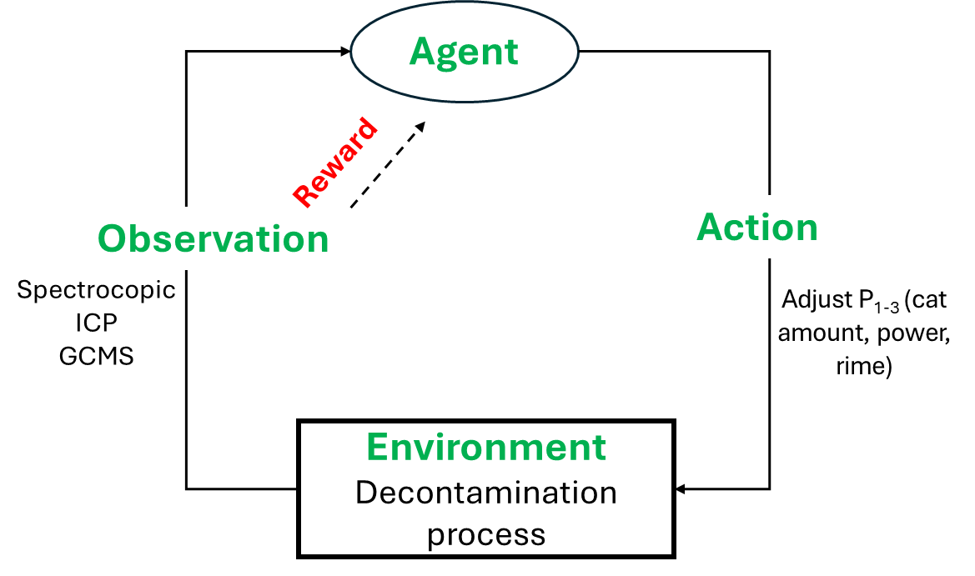

*Comment to ICP, GCMS: e reinforcement learning can help to optimize the decision-making process on when to use ICP-MS or GC-MS based on real-time feedback from Raman spectroscopy.*

1. Optimization algorithms (e.g. genetic algorithms and particle swarm optimization): they will help to find the most efficient combination of parameters (e.g., temperature, pressure, cleaning agents) that achieve maximum decontamination with minimum energy consumption.

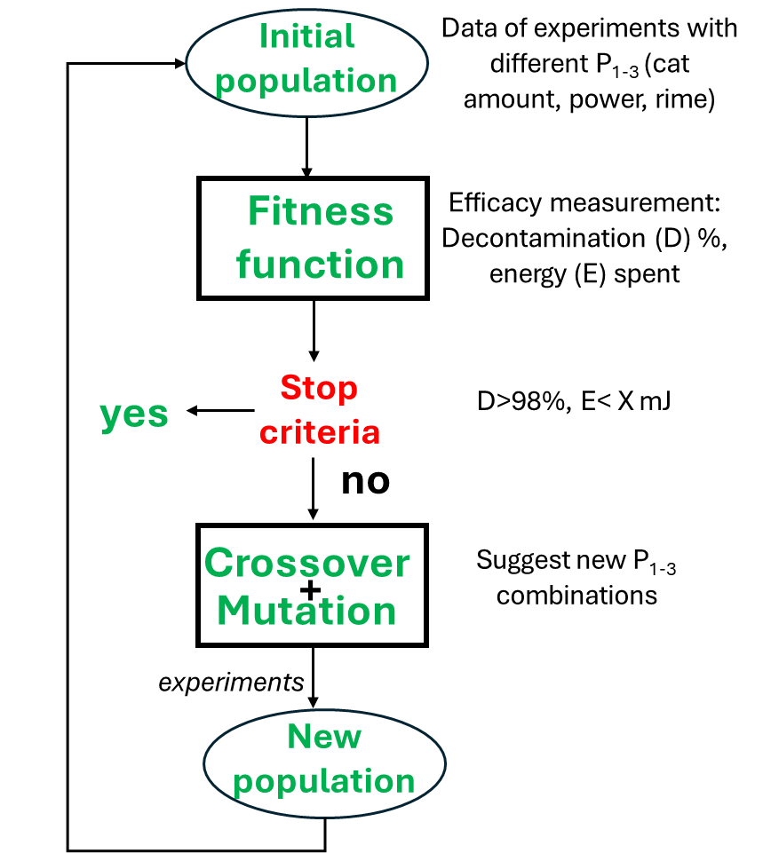

*Suggested visualization tools:*

1. Visualization of the learning process of RL models: display how the system’s parameters are being adjusted in real-time based on AI-driven feedback, showing the immediate impact on performance metrics
2. Parameter space exploration: different parameter of chemical combinations process must be visualized, showing how the algorithm navigates the solution space to find the optimal conditions of decontamination

1.3. Innovation content (<10000 characters)

Various chemical substances can be found in plastic waste, typically divided into Intentionally Added Substances (IAS), added on purpose during the processing of plastics, such as additives, inks, and adhesives, and Non Intentionally Added Substances (NIAS). The latter are substances that come into contact with plastics during their life cycle, such as food residues, fats, cosmetics and dust. Often, these (N)IAS are difficult to remove, and the presence of these contaminants introduces several problems such as the immiscibility of polymers, inferior mechanical properties, dark-colored and bad- smelling recyclate, and legal implications (certified reference mate rials, persistent organic pollutants, and substances of very high concern).

Existed decontamination procedure

Disadvantages

Need new procedure - effective and energy saving

About plasmonic decontamination

Need in automatization to reduce number of experiments

Multiple measurements are required to meet current regulations. These measurement produce vast amounts of complex data that require sophisticated analysis techniques. Variation of each parameter

The challenge lies in effectively interpreting this data in real-time. Developing automated, reliable methods for data interpretation and integration into carbon materials synthesis is a big challenge. There are a few examples of linear models post-processing for kinetics studies 26,27, however, they are not applicable for carbon materials preparations, but for analysis.

2. Consortium

2.1. Composition of project team (<3000 characters)

Technical University of Vienna

The team represented by Dr. Guselnikova has expertise in designing new materials for catalytic applications, especially for photocatalysis. She is highly experienced PI in the field of plasmonic materials development and application proved by >7 corresponding author papers (ACS Catal., Nature Comm., Small etc), 4 projects and 3 patents (see CV for more details). One PhD student will be hired (requirements are experience in organic chemistry/heterogeneous catalysis/nanomaterials). One PhD student with relevant qualification (Bachelor degree is in chemistry, materials science; experience in catalysis and/or synthesis of nanomaterials) will be hired for this project.

FOTECH (Forschungs- und Technologietransfer)

LuxActive KG

Moncon

Redeem

Steinbeis PolyVert GmbH -plastic recycling company letter of intent

3. Benefit and exploitation

3.1. Benefit for customers and users and in terms of sustainability (<5000 characters)

Customers and end users are

-AI company who could create a optimization protocols for other procedures

-plastic recycling company

-washing KLINGER BOTTLE WASHING MACHINES ; https://www.keg-gruber.at/en/contact.html

3.2. Exploitation by project participants (<4000 characters)

**TUV new expertise in light driven processes**

**FOTECH**

**LuxActive new direction for waste management**

**System additional information**

Key competences of the persons involved:

Technical University of Vienna

The scientific supervision of the project is provided by Dr. Olga Guselnikova carried out. Her main research area is plastic waste recycling, e.g. PP masks and PET bottles. Secondly, she is an expert in photocatalysis and plasmonic material synthesis for wide range of chemical reaction (oxidation, reduction, gas conversion). Furthermore, Dr. Guselnikova also carried out material characterization and product analysis at TUC. Therefore, Dr. Guselnikova has all the necessary skills required for the development of a technological concept for light-driven waste upcycling. One PhD student with relevant qualification (Bachelor degree is in chemistry, materials science; experience in catalysis and/or synthesis of nanomaterials) will be hired for this project.

FOTECH (Forschungs- und Technologietransfer)

SWISDATA

Moncon

Redeem

Results from other projects:

Technical University of Vienna

The results provided from the previous project “Development of new functional materials for plasmon induced transformations of CO2” (Russian Science Foundation, 20-73 00151), which applicant Dr. Olga Guselnikova carried out in the previous place of work could bring synergy for the planned project. In a previous project, she test light driven activity of AuNPs. The results provided from the previous project “Hybrid mesoporous plasmonic film: from smart sensing to green technologies” (P20370, Japan Society for the Promotion of Science, 2021-2023) which applicant Dr. Olga Guselnikova carried out in the previous place of work could bring synergy for the planned project. The synthesis of porous plasmonic structures applicable as substarte for reactor prototype will be adapted in this project.

FOTECH (Forschungs- und Technologietransfer)

SWISDATA

Moncon

Redeem

Project-relevant infrastructure:

Technical University of Vienna

Facilities for plasmonic substrates analysis such as SEM, infrared spectroscopy, goniometry are available at TUV. Sufficient laboratory space for performing the experiments is available. There is a UV-Vis spectrometer for analysis of optical properties. Inductively coupled plasma mass spectrometry (ICP-MA), Gas chromatography (GC-MS) and liquid chromatography (HPLC-MS): analysis of purity of waste materials.

FOTECH (Forschungs- und Technologietransfer)

SWISDATA

Moncon

Redeem

Third-party tasks:

Technical University of Vienna

TEM of prepared NPs will be recorded in central laboratories of TUV.

FOTECH (Forschungs- und Technologietransfer)

SWISDATA

Moncon

Redeem